Assignment 2

1.creat Donut chart
Step 1: Open Worksheet
1. Open Tableau.
2. Go to a New Worksheet.
3. Make sure you have field like:
Payment Method (Dimension)
Sales / Amount (Measure)
Step 2: Create Pie Chart
1. Drag Payment Method → to Marks → Color.
2. Drag Sales (Amount) → to Marks → Angle.
3. Drag Sales again → to Label.
4. In Marks, change chart type to Pie.
5. Increase Size to make the pie bigger.
Now you will see a normal Pie Chart.
Step 3: Create Donut (Hole in Center)
1. Create a calculated field:
Right click in Data pane → Create → Calculated Field
Name: Zero
Formula:
0
Click OK
2. Drag Zero to Columns.
3. Drag Zero again to Columns (you will get two Zero pills).
Step 4: Create Dual Axis
1. Right-click on the second SUM(Zero) in Columns.
2. Click Dual Axis.
3. Right-click again → Synchronize Axis.
4. Hide headers (Right click axis → Show Header uncheck).
Step 5: Format Donut
First Marks Card (Outer Pie)
1. Select SUM(Zero) (first one).
2. Chart type = Pie.
3. Keep:
Payment Method → Color
Sales → Angle
Sales → Label
4. Increase Size.
Second Marks Card (Inner Circle)
1. Select SUM(Zero) (2).
2. Remove all fields.
3. Change color to White.
4. Reduce Size to create donut hole.
5. Drag Sales to Label → Edit label → type:
Total
<SUM(Sales)>
Step 6: Final Formatting
1. Edit title → Sales share by payment method.
2. Adjust colors if needed.
3. Center the view (Fit → Entire View).
Output
You will get a Donut Chart showing:
Cash
Credit Card
E-wallet
Total value in center

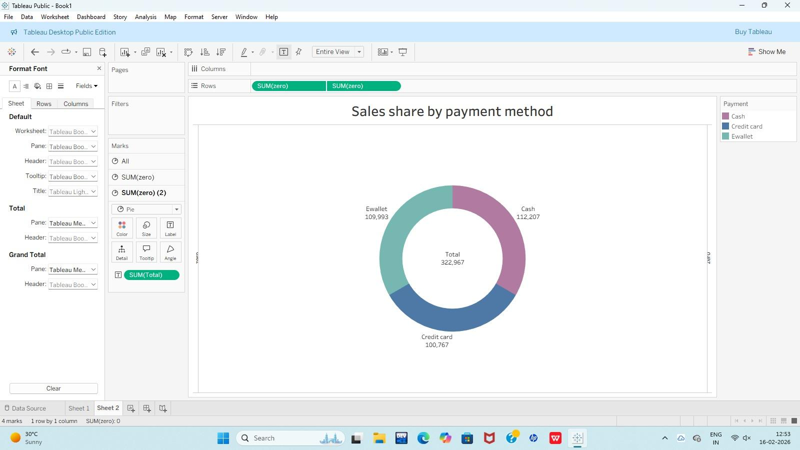

2.Create area chart
1. Open Tableau → Connect to your dataset.
2. Drag Date → Columns → change to MONTH(Date).
3. Drag Total (Sales) → Rows.
4. In Marks, change chart type to Area.
5. Drag Branch → Color (to show A, B, C separately).
6. Drag Total → Label (optional, to show values).
7. Click Show Me → ensure Area Chart is selected.
8. Edit the Title → “Monthly Performance of Branches”.
Done. This will show monthly sales comparison for each branch in a stacked area chart.

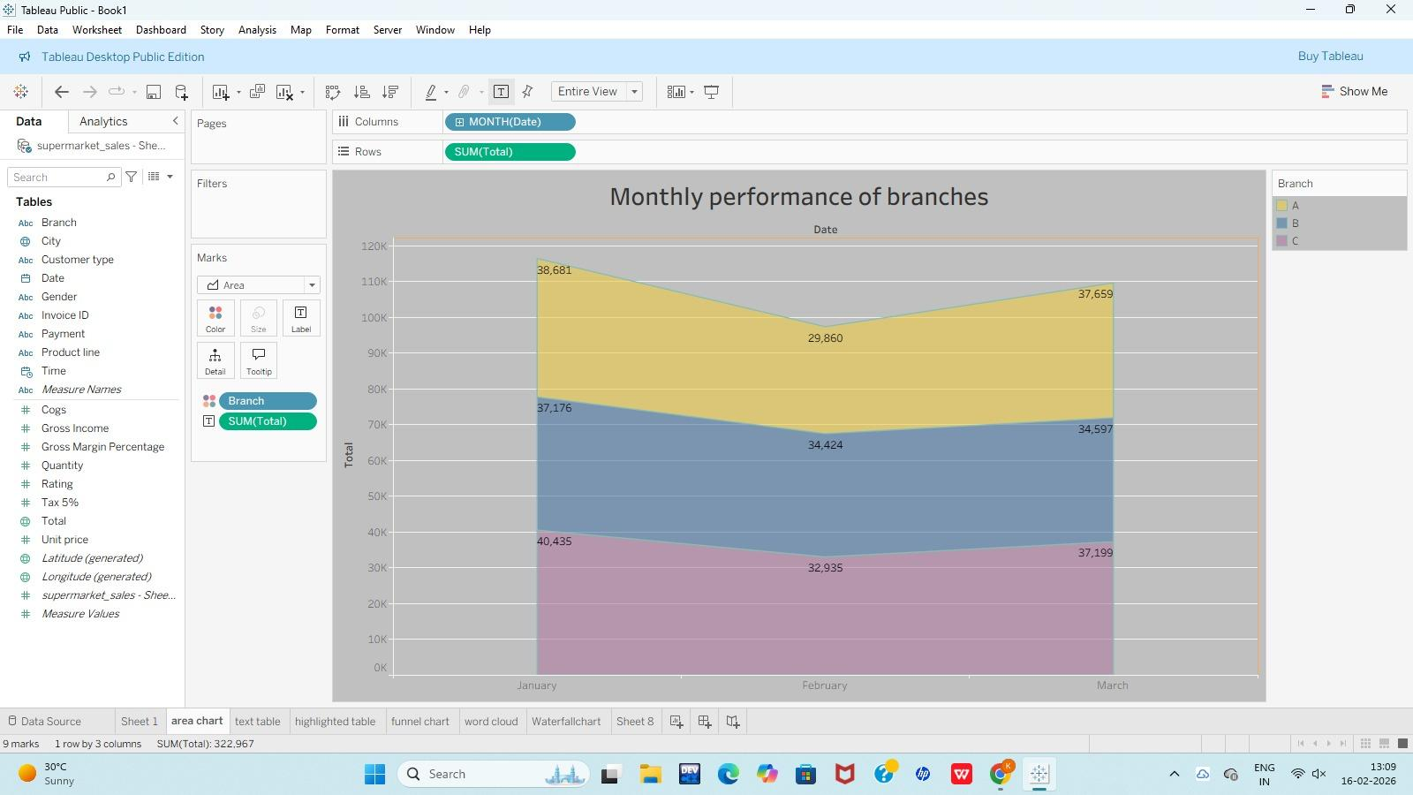

3.Create text table
1. Open Tableau and connect to your dataset.
2. Drag Branch → Columns.
3. Drag Product line → Rows.
4. Drag Total (Sales) → Marks → Text.
5. In Marks, make sure the chart type is Text (or click Show Me → Text Table).
6. Adjust Format / Alignment if needed.
7. Edit the title to “Product line sales overview”.
Done – This shows Product line sales for each Branch (A, B,C).
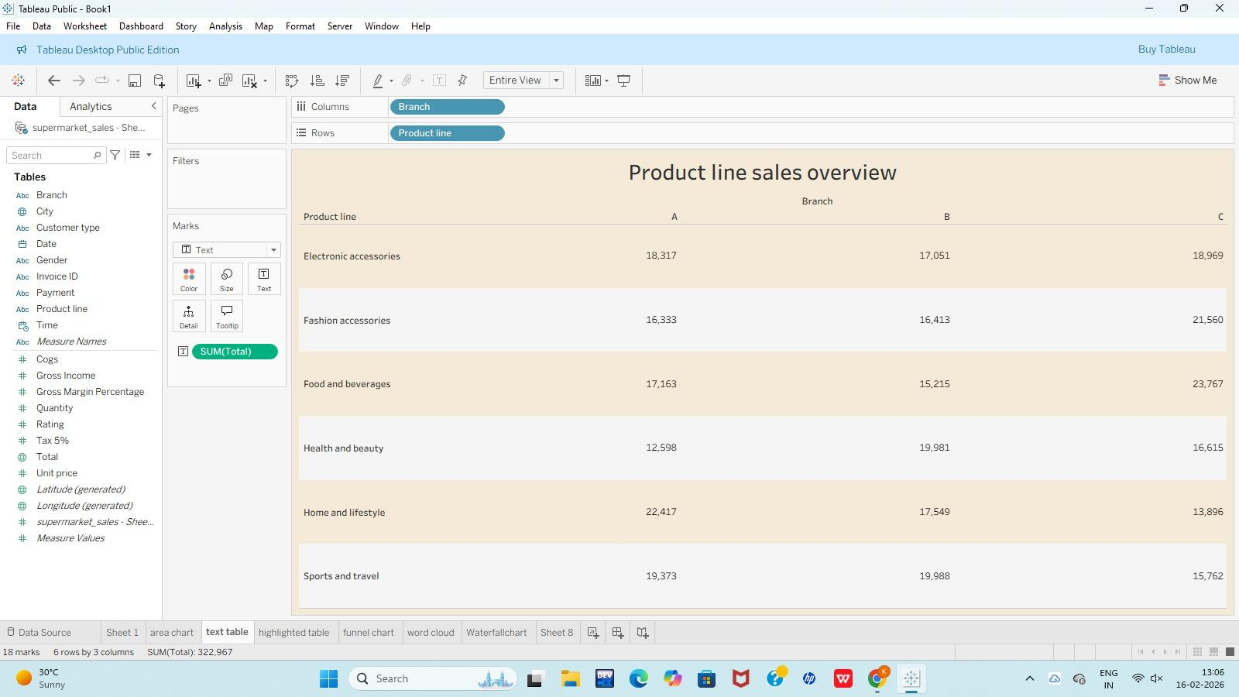

4.Create Higliti table
Step 1: Open Worksheet
1. Open Tableau Public.
2. Load your dataset (Supermarket Sales).
3. Click Sheet 1 (or create a new worksheet).
Step 2: Add Dimensions
1. Drag Payment → Columns.
2. Drag Product line → Rows.
Now you will see a text table structure.
Step 3: Add Sales Measure
1. Drag Total → Marks card.
2. Drop it on:
Text (Label) – to show numbers.
Color – to create color intensity.
Make sure aggregation is SUM(Total).
Step 4: Change Mark Type to Highlight Table
1. In the Marks card, click the drop-down.
2. Select Square
(or)
Click Show Me (top right) → choose Highlight Table.
Now each cell will be filled with color based on sales
Step 5: Adjust Colors
1. Click Color → Edit Colors.
2. Choose a color palette (e.g., Orange or any gradient).
3. Click OK.
Higher sales = darker color.
Step 6: Format Labels
1. Click Label on the Marks card.
2. Check Show mark labels (if not visible).
3. Format numbers if needed:
Right-click SUM(Total) → Format → Number → Currency/Number.
Step 7: Add Title
1. Go to Worksheet → Show Title.
2. Double-click the title.
3. Rename to:
Payment mode contribution to sales.
4. Click OK
1. On the toolbar, change Standard → Entire View.
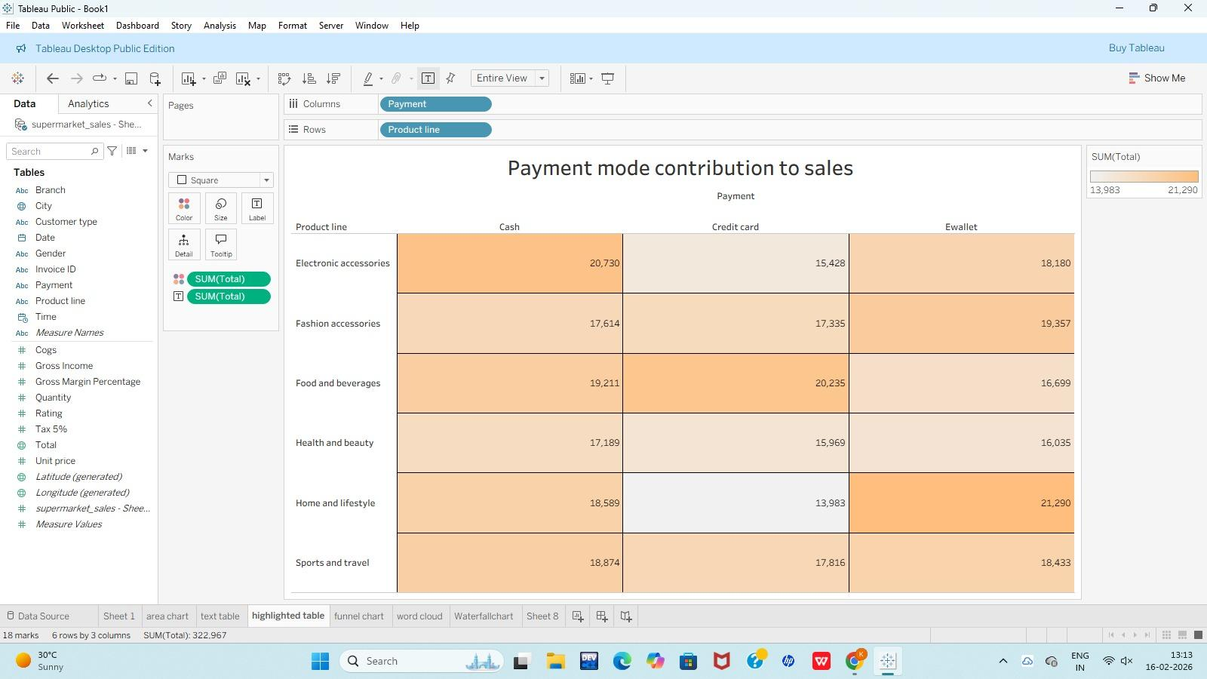

1. Open Worksheet
Open Tableau Public
Click New Worksheet (Sheet).
2. Select Data
From left Data pane, drag Product line → Text in Marks card.
3. Add Sales Measure
Drag Total (or Sales) → Size in Marks card.
(This controls word size based on sales value.)
4. Change Chart Type
In Marks card, click dropdown.
Select Text.
Click Show Me (top right).
Choose Word Cloud.
5. Add Color
Drag Product line → Color.
Each category will show in different colors.
6. Adjust Word Size
Click Size → increase slider to make words bigger.
7. Format Title
Go to Worksheet → Show Title.
Double-click title.
Type: Product Category Sales Insights.
Click OK.
8. Change Background (Optional)
Go to Format → Shading.
Under Worksheet, choose light color.
9. Fit the View
On top toolbar, select Fit → Entire Vi

